**MUNYANEZA KENNY ROGER**

**23043**

**MAJOR DIFFERENCE BETWEEN LINEAR AND NON-LINEAR DATA STRUCTURES**

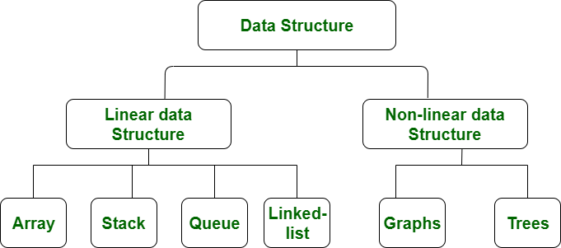

|  |  |
| --- | --- |
| Linear Data Structure | Non-linear Data Structure |
| In a linear data structure, data elements are arranged in a linear order where each and every element is attached to its previous and next adjacent. | In a non-linear data structure, data elements are attached in hierarchically manner. |
| In linear data structure, single level is involved. | Whereas in non-linear data structure, multiple levels are involved. |
| Its implementation is easy in comparison to non-linear data structure. | While its implementation is complex in comparison to linear data structure. |
| In linear data structure, data elements can be traversed in a single run only. | While in non-linear data structure, data elements can’t be traversed in a single run only. |
| In a linear data structure, memory is not utilized in an efficient way. | While in a non-linear data structure, memory is utilized in an efficient way. |
| Its examples are: array, stack, queue, linked list, etc. | While its examples are: trees and graphs. |
| Applications of linear data structures are mainly in application software development. | Applications of non-linear data structures are in Artificial Intelligence and image processing. |